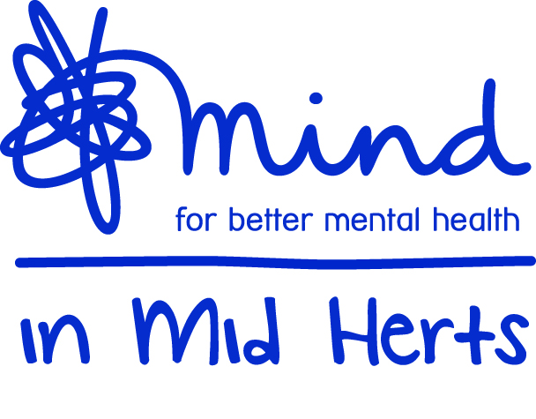
Mind in Mid Herts
Minutes of AGM
Tuesday 6th November 2018

Welcome
Welcome by St Albans Mayor Rosemary Farmer

Presentations
Short presentations made by the following Service Users;
- Scene from Cinderella by Caroline Talbot, Robert Hockington from Drama Group St Albans
- Poem by Anastasia Raymond St Albans Creative Writing Group
- Poem by Katie Wilson from Stevenage
- Short stories by Mike Bungay and Chantelle from Stevenage Creative Writing Group
Talk from Shona Davies – Fundraiser

AGM Meeting
Members approved the minutes of the last AGM meeting. Minutes and Agenda of the meeting were circulated to all present.

Election of Trustees
Appointment of new trustee Joanne Couchman – profile of the new trustee was circulated to all present and was elected by a show of hands.
Reappointment of trustees due to retire – Alexis Ernst, Peter Walsh and Jessica Attard were re-elected by a show of hands.
New prospective trustees Ian Callaghan and Shone Davies were introduced.

Annual Report
Annual review was circulated.
As a snapshot over 1500 people have used the services at MiMH.
MiMH ran over 1800 groups in the year
74% that attended felt less isolated
84% given support and information

Volunteer Coordinator presentation to Peer Supporters
The Volunteer Coordinator talked about the importance the role of Peer Supporters is and how they contribute to the smooth running of our groups; certificates were presented to appreciate the value we place on them: Ian Jordan, Trevor Figg, Fern Holland, Shane Dolan, Michael Harniman, Wendy Rose and David Arrand

Donations
Thanks to the Tewin Trekkers our largest challenge fund raising group this year completed the Three Peak Challenge of 26 miles in July and raised £7500.00 for Mind in Mid Herts.
Thank you to Dave Hattam, Kelly Hattam, Oliver White, Heather Pearson, Barry Hares, Joanne Hares, Leanne Elia, Gill Walker, Lauren Walker, Geraldine Marshall, Verity Stuart-Thompson, Jack Skeggs, Rob Spicer, Matt Page, Jonathan Searles, Jess Boulton.

We heard from Shlomit and Ehud Eliashar who have made a large donation to MiMH’s in memory of their son Alon.

Talk from John Henry Newman School students and presentation for their outstanding contribution to raising awareness of Mental Health.

Close
Paul Ronald thanked all for attending and thanked all at Mind in Mid Herts for all their work and contribution throughout the year.
Paul thanked Sharn Tomlinson for her hard work and 10 years of service and presented Sharn with a gift and flowers as a token of appreciation.

