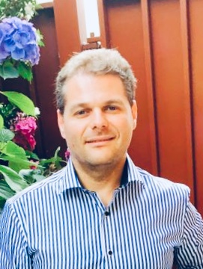

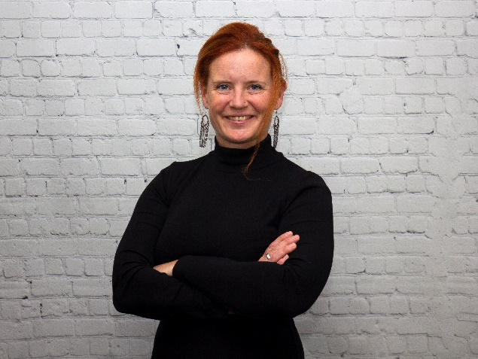

**Narcis Balalau**

Narcis has over 20 years’ experience in the end-to-end business cycle within the food industry, global food supply chain management, and marketing, financial management reporting & manufacturing process knowledge. He has worked in a wide range of industries including food, manufacturing, retail and FMCG.

He has a Masters in Management, Specialising in Business Administration from Birkbeck College, University of London, United Kingdom and he is a Member of Chartered Institute of Procurement and Supply

**Shona Davies**

Shona is a Senior Operations Executive who turns strategy into delivery - helping companies succeed when launching and growing their health-centred business.

With 16 years in the Digital Health space working with Pharmaceuticals, Publishers, Societies and Agencies, Shona has the skills and network to help start-ups to PLCs develop their products and services and create efficient and effective operations processes. She coaches and mentors teams to improve skills and productivity.

In the mental health space, Shona campaigns, consults and coaches both individuals and organisations as well as working as a trustee for MiMH. With her own lived-experience of mental ill-health, she is committed to ensure the right support is available to anyone who needs it.



**Isaac Kenyon**

Being open and transparent my personal connection with a Mind in Mid Herts (MiMH) grew from when I experienced high levels of anxiety last year; with no medical treatment I found to find a solution that worked for me which I call “outdoor time”. I was aware of MiMH as a local resident of Colney Heath, however, it was only when I experienced my own mental health issues did I realise how important a charity like this is in providing prevention, recovery and support services to those like myself in Hertfordshire.

I have always participated in adventurous endeavors such as rowing the Atlantic Ocean unsupported and swimming the English Channel as well as many others I have started a campaign to inspire others to reach their potential, it is targeted at those whose daily lives involve excessive “screen time” to get more outside time in nature for that wellbeing balance. Next year I will cycle from John O’Groats the most northern point of mainland Scotland to Lands End the most southern point of England for MiMH.

I looked at the values and the mission of the charity and it aligned with my own. I want to help those who need help with their mental health. I want to give to the community as it is where I get the most satisfaction when helping those that need it. It is important for me to listen and facilitate change by contributing and add value to the strategy/guidance of the charity in compliance with governmental

law, whilst also fundraising through my adventures and giving talks to the community (see my website: [www.isaackenyon.com](http://www.isaackenyon.com)) on behalf of the charity. I have been the president of my university swimming club as well as the geological society of the university so am familiar with how committees are run. I have experience in finance working as an accounting business analyst so understand the financial side of the charity and effective in outreach raising over £120k in 6 months to row across the Atlantic Ocean.

Being upfront I have not been involved in a charity this large before and am interested to learn more and challenge myself in a trustee role as well as getting hands on with volunteering.

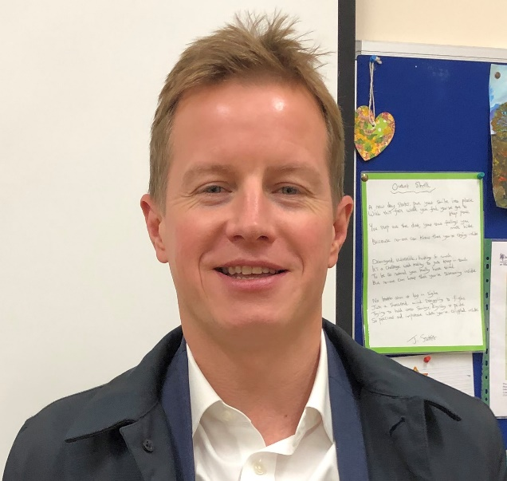

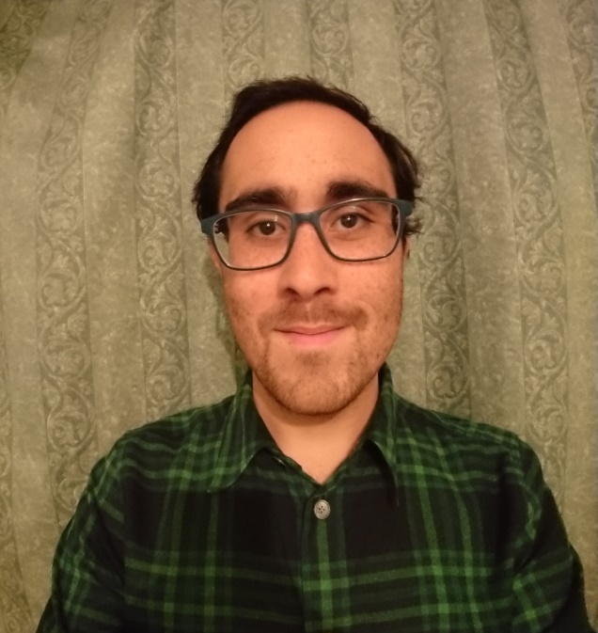

**Ian Callaghan**

Ian is a Chartered Accountant with over 20 years’ experience working in a number of Senior Finance roles in Banking.

Ian was introduced to Mind in Mid Herts through the support Lloyds Bank Foundation has provided to MiMH over the last few years.

Ian has provided support to Sharn, our CEO, in the recent past and was delighted to be asked to join the Board of Trustees. Ian brings a strong Finance background and is keen to get involved in a number of areas to support the wider management team.

**Dominic Mahabir**

Dominic has many years’ experience in the charitable sector having previously worked for the St Albans Centre for Voluntary Service where he managed a charitable Trust providing grants for older adults. He developed strong relationships with the NHS clinical commissioning group and County Council; he increased the brand awareness of the charity leading to it being able to help many more people and launched its website during a very successful public event. He currently works in finance with experience in process improvement and project management

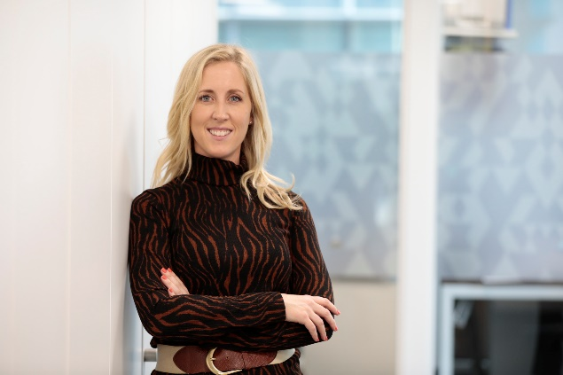

**Sandy-lee Connolly (ACIS)**

**Governance Professional and Deputy Company Secretary at Keller Group plc**

Sandy-lee is Deputy Company Secretary of Keller Group plc and is responsible for the day-to-day management of the Secretariat function and for ensuring that Keller complies with its legal and governance obligations.

Having worked in the Governance arena for over 17 years, she believes that compliance should be ‘***real and relevant***’ and has always sought new and creative ways of demonstrating this. Sandy-lee is a member of Keller’s Data Protection Steering Committee, has delivered on a number of global initiatives, and advises on legal, regulatory and governance developments.

In 2018, Sandy-lee was nominated as ‘***Governance Professional of the Year’*** at the ICSA Awards Ceremony and was shortlisted alongside a number of strong contenders.

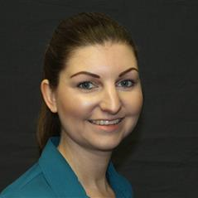

**Laura Tyrrell**

Laura has a wealth of experience within the mental health sector, this includes working for a mental health charity where she evaluated the services for adults within residential care homes and looked to improve them.

She has also worked in the NHS for many years, including at a mental health NHS Trust, where she implemented a new step-down service for patients. Plus she has worked within the London region, where she worked on improving the section 136 pathway and also the support offer for callers to 111 who require mental health support. In addition, she previously led the engagement of a mental health awareness campaign called Thrive LDN, which the Mayor of London fronted.

She has also worked at national level in the NHS, where she previously helped mental health trusts (and other sectors) to improve their data quality and identify where improvements could be made to their services. She now currently works within the adult mental health policy team within NHS England and NHS Improvement, and leads the implementation of the long-term plan recommendations for mental health in relation to acute and crisis care.

She was previously a Trustee for Sound Minds, a mental health charity based in South West London, and was there for approximately 3 years. During which time she managed a national peer support event, called Peerfest on behalf of the charity, which sought to raise awareness of available peer support options, encourage open conversations about mental health and highlight how different arts can support mental wellbeing.