**Don’t Sleep on your Mental Health!**

We are fundraising for

Mind in Mid Herts

Event:

Date:

Time:

Location:

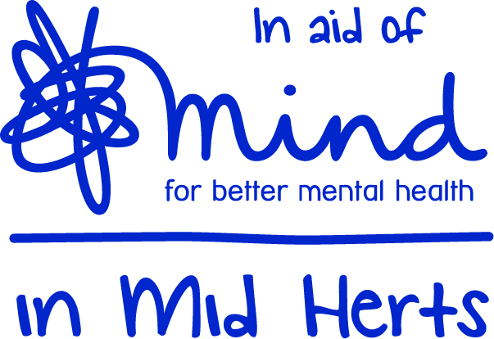

For further details contact:

Charity Number- 1101678