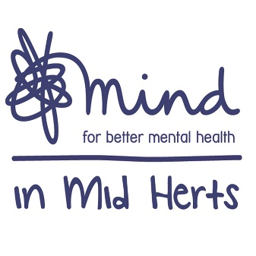
‘Living Well’
Courses for Wellbeing & Recovery

Our ‘Living Well’ courses have been designed to support people make positive changes in their lives. Informed by Cognitive Behavioural Therapy (CBT) principles these guided self-help courses support people to identify unhelpful thinking patterns and behaviours, whilst offering new coping strategies.

These digital courses will be run via Zoom; giving all the benefits of face-to-face support from the comfort of peoples own homes. Each group will be no more than 16 participants and facilitated by our experienced workers at Mind in Mid Herts. Each course will be 90 minutes long and structured over 4 consecutive weeks.

This communication pack as being designed so that everyone can get involved to spread the word that Help is still available and accessible.
If you would like to support, simply copy and paste onto your social network platforms.
We appreciate everyone’s support during this very difficult time.

 | Facebook | Twitter | Instagram
 | With the country on lockdown, @mindinmidherts has moved their ‘Living Well’ courses to take place online.  The courses have been designed to support people with making positive changes in their lives. Informed by Cognitive Behavioural Therapy (CBT) principles these guided courses will help you in identifying detrimental behaviours whilst offering new coping strategies.  They’ll be run via Zoom; giving you all the benefits of face-to-face support from your own homes.  Who’s it for?  Anyone aged 16+ for a maximum of 16 participants only.  Cost: £20  Book at: https://mindinmidherts.eventbrite.co.uk/  Or the Mind in Mid Herts website  or email them at: training@mindinmidherts.org.uk | @MindInMidHerts_ has now moved their #LivingWell courses online.  Informed by #CBT principles they'll help you identify detrimental behaviours & offer coping strategies.  They’ll be run via @zoom_us for a max. of 16 participants.  Book here -> https://mindinmidherts.eventbrite.co.uk/ | With the country on lockdown, @mindinmidherts_ has moved their #LivingWell courses online.  The courses have been designed to support people with making positive changes in their lives.  Informed by Cognitive Behavioural Therapy (#CBT) principles these guided courses will help you in identifying detrimental behaviours whilst offering new coping strategies.  They’ll be run via @zoom.usc  giving you all the benefits of face-to-face support from your own homes.  Who’s it for?  Anyone aged 16+ for a max. of 16 participants only.  Cost: £20  Book at: https://mindinmidherts.eventbrite.co.uk/  Or the Mind in Mid Herts website  or email: training@mindinmidherts.org.uk  #Mindinmidherts #Hertfordshire #mentalhealthawareness #mentalwellbeing #mentalhealth #training #onlinetraining #online #LivingWell #FeelingWell #onlinecourses #Mentalhealthtraining #MentalHealthCourses #learn #keepwell #staysafe #learnfromhome #bettermentalhealth #wellbeingmatters #home #stayathome #socialdistancing
Picture for post | 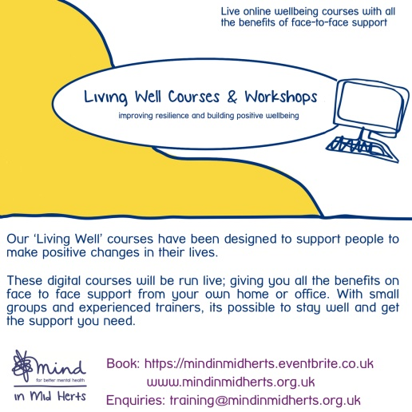
 | @mindinmidherts’ first online course ‘Feeling Well’ part of their ‘Living Well’ courses is taking place in Spring 2020.  Book your place via: mindinmidherts.eventbrite.co.uk/  If you’d like to gain an understanding of depression; its causes & symptoms & the chance to develop a range of strategies to effectively manage your mood, then book on, as there are only 16 places available. | @MindInMidHerts_ first online course #FeelingWell part of their #LivingWell courses is taking place in Spring 2020.  If you’d like to gain an understanding of #depression & develop strategies to manage your mood then book here: mindinmidherts.eventbrite.co.uk/  Only 16 places available. | @mindinmidherts_ first online course ‘Feeling Well’ part of their ‘Living Well’ courses is taking place in Spring 2020.  Book your place via: mindinmidherts.eventbrite.co.uk/  If you’d like to gain an understanding of depression; its causes & symptoms & the chance to develop a range of strategies to effectively manage your mood, then book on, as there are only 16 places available.  #Mindinmidherts #Hertfordshire #mentalhealthawareness #mentalwellbeing #mentalhealth #training #onlinetraining #online #LivingWell #FeelingWell #onlinecourses #Mentalhealthtraining #MentalHealthCourses #learn #keepwell #staysafe #learnfromhome #bettermentalhealth #wellbeingmatters #home #stayathome #socialdistancing
Picture for post | 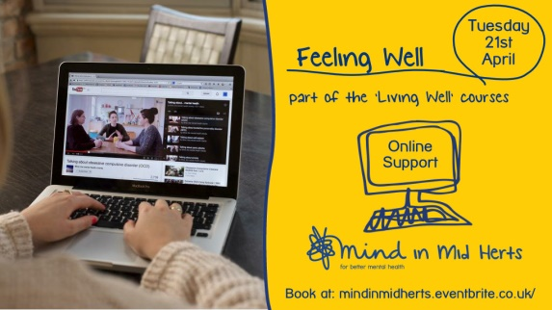 |  | 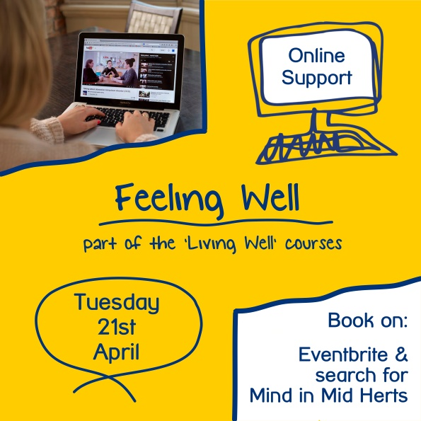
 | @mindinmidherts’ next online support course ‘Learning to Relax’, part of the ‘Living Well’ series, is taking place via Zoom (free to download) in Spring 2020.  This course aims to equip participants with a good understanding of what stress is & to equip learners with a range of strategies to effectively manage their stress.  Book onto the course via their website or: mindinmidherts.eventbrite.co.uk/  Cost: Only £20 | @MindInMidHerts_ online support course #LearningtoRelax, part of the #LivingWell series, is taking place via @zoom_us in Spring 2020  Attendees will gain an understanding of what #stress is & strategies to manage their own.  Book via their website or: mindinmidherts.eventbrite.co.uk/ | @mindinmidherts_ next online support course ‘Learning to Relax’, part of the ‘Living Well’ series, is taking place via Zoom (free to download) in Spring 2020.  This course aims to equip participants with a good understanding of what stress is, & to equip learners with a range of strategies to effectively manage their stress.  Book onto the course via their website or: mindinmidherts.eventbrite.co.uk/  Cost: only £20  #Mindinmidherts #Hertfordshire #mentalhealthawareness #mentalwellbeing #mentalhealth #support #onlinesupport #online #LivingWell #LearningtoRelax #onlinecourses #Mentalhealth #stress #managingstress #MentalHealthCourses #learn #keepwell #relax #newskills #staysafe #learnfromhome #bettermentalhealth #wellbeingmatters #home #stayhome #socialdistancing
Picture for post | 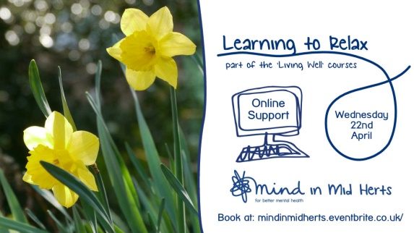 |  | 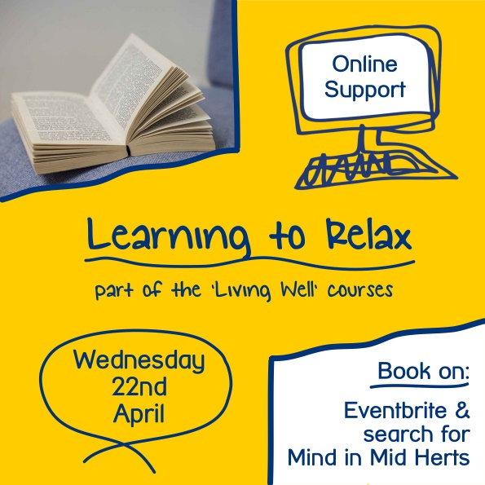
 | As part of their ‘Living Well’ online support courses, @mindinmidherts are offering a ‘Building Courage’ course on the Zoom App, for up to 16 people.  For only £20 gain a better understanding of what anxiety is, how it is maintained & equip yourself with a range of strategies to effectively manage your anxiety.  Book on their website or here: mindinmidherts.eventbrite.co.uk/ | As part of their #LivingWell online support courses, @MindInMidHerts_ are offering a #BuildingCourage course on the @zoom_us App, for up to 16 people.  For only £20 #learn about #anxiety & equip yourself with how best to manage your own.  Book: mindinmidherts.eventbrite.co.uk/  #support | As part of their ‘Living Well’ online support courses, @mindinmidherts_ are offering a ‘Building Courage’ course on the Zoom App, for up to 16 people.  For only £20 gain a better understanding of what anxiety is, how it is maintained & equip yourself with a range of strategies to effectively manage your anxiety.  Book on their website or here: mindinmidherts.eventbrite.co.uk/  #Mindinmidherts #Hertfordshire #mentalhealthawareness #mentalwellbeing #mentalhealth #training #onlinetraining #online #LivingWell #BuildingCourage #courage #skills #onlinecourses #Mentalhealthtraining #MentalHealthCourses #learn #keepwell #staysafe #learnfromhome #bettermentalhealth #wellbeingmatters #home #stayathome #socialdistancing
Picture for post | 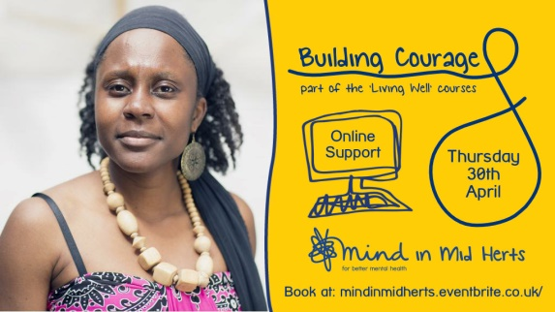 |  | 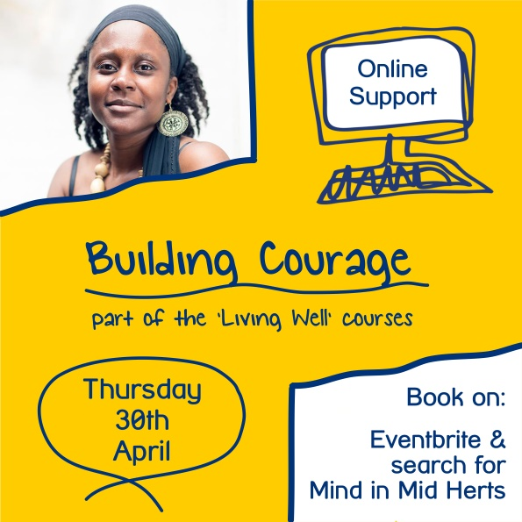
 | Whether you’re working from home at the moment or not, @mindinmidherts is offering an affordable course, ‘Staying Well at Work’ which aims to support participants to build their resilience & gain an understanding of what impacts their wellbeing at work, as well as how to build positive wellbeing & manage change effectively.  Location:  Online via the Zoom app – completely free to download on any laptop, desktop, android/smartphone etc.  The course is for anyone age 16+ but be quick to book as the max. number of participants is 16!  Guarantee yourself a place now by booking via their website or here: mindinmidherts.eventbrite.co.uk/ | @MindInMidHerts_ is offering an affordable course, #StayingWellatWork which aims to support you in building #resilience & a positive work #wellbeing as well as #ManageChange.  Details:  Spring 2020 On Zoom.  Guarantee yourself a place now & book here: mindinmidherts.eventbrite.co.uk/ | Whether you’re working from home at the moment or not, @mindinmidherts is offering an affordable course, ‘Staying Well at Work’ which aims to support participants to build their #resilience & gain an understanding of what impacts their #wellbeing at work, as well as how to build positive wellbeing & #ManageChange effectively.  Date:  Spring 2020  Location:  Online via the Zoom app – completely free to download on any laptop, desktop, android/smartphone etc.  The course is for anyone age 16+ but be quick to book as the max. number of participants is 16!  Guarantee yourself a place now by booking via their website or here: mindinmidherts.eventbrite.co.uk/  #Mindinmidherts #Hertfordshire #mentalhealthawareness #mentalwellbeing #mentalhealth #training #onlinetraining #online #LivingWell #StayingWellatWork #workwellbeing #skills #onlinecourses #Mentalhealthtraining #buildreilience #postive #MentalHealthCourses #learn #keepwell #staysafe #learnfromhome #bettermentalhealth #wellbeingmatters #home #stayathome #socialdistancing
Picture for post | 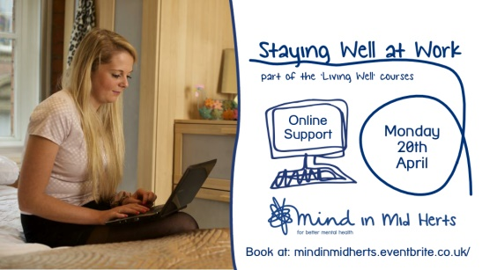 | 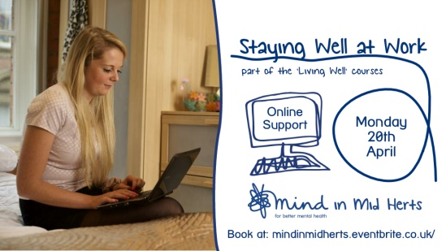 | 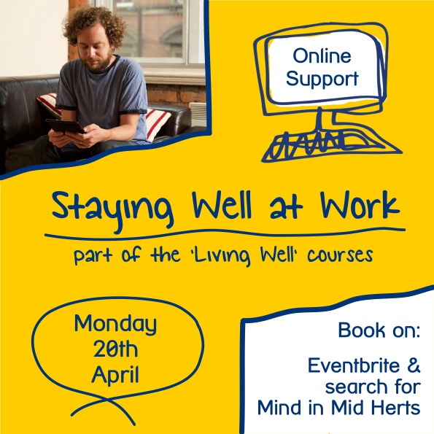
 | This Mental health Awareness week (18-25th of May) @mindinmidherts will be running a workshop for participants around sleep, the theme of the week.  This workshop will provide participants with a better understanding of the importance of sleep and explore strategies to improve it.  This the final course in their ‘Living Well’ online support series.  Don’t miss out & book a place on: mindinmidherts.eventbrite.co.uk/  Make sure to download the free app Zoom to take part - you must be 16 years & above. | This #MentalHealthAwarenessWeek, 18-25 May @MindInMidHerts_ will be running a workshop around #sleep.  It's the final course in their #LivingWell online series. Discover the benefit of sleep on MH & explore ways to improve it.  Don’t miss out & book here: mindinmidherts.eventbrite.co.uk/ | This #MentalHealthAwarenessWeek (18-25th of May) @mindinmidherts will be running a workshop for participants around sleep, the theme of the week.  This workshop will provide participants with a better understanding of the importance of sleep and explore strategies to improve it.  This the final course in their ‘Living Well’ online support series.  Don’t miss out & book a place on: mindinmidherts.eventbrite.co.uk/  Make sure to download the free app Zoom to take part - you must be 16 years & above.  #Mindinmidherts #Hertfordshire #DontSleeponYourMentalHealth #mentalhealthawareness #mentalwellbeing #mentalhealth #online #LivingWell #sleep #sleepingwell #sleeptechniques #importanceofsleep #skills #onlinecourses #Mentalhealthtraining #MentalHealthCourses #learn #keepwell #staysafe #learnfromhome #bettermentalhealth #wellbeingmatters #home #stayathome #socialdistancing
 | 