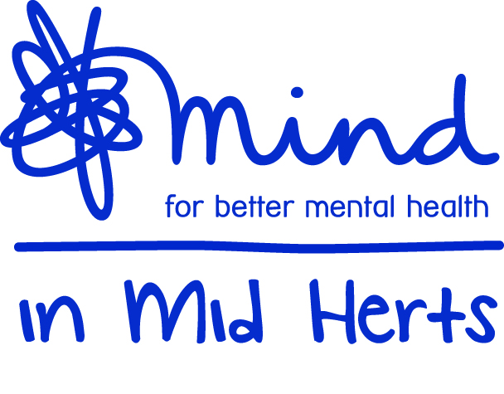
Mind in Mid Herts
(the ‘Company’)
Minutes of the Annual General Meeting of the Company held
on Friday 27 November 2020 at 4pm by videoconference

Directors’ Present Paul Ronald (Chair)
Narcis Balalau
Rose Benyon
Matthew Caffrey
Ian Callaghan
Sandy-lee Connolly
Shona Davies
Alexis Ernst
Isaac Kenyon
Dominic Mahabir
Neil Margereson
Laura Tyrell
Peter Walsh

- Welcome & Quorum
The Chair welcomed all those who were able to join the Annual General Meeting (the ‘AGM’). Whilst the Board valued the opportunity to meet, listen and respond to members in person at the AGM, the Chair confirmed that a decision to convene electronically (in accordance with the provisions of the Corporate Insolvency and Governance Act 2020) had been made in light of the pandemic.
There being a quorum present, the Chair declared the meeting open.

- Formal business of the meeting

The Notice of Meeting (the ‘Notice’) dated 5 November 2020 was taken as read. The Chair confirmed that no questions on the Statement of Accounts or any other ordinary business of the meeting had been received from members.
All resolutions as set out in the Notice had been put to a vote by asking members to complete their proxy forms in advance of the AGM. The results of the proxies were set out below:
Resolutions | Votes For | % | Votes Against | %
Statement of Accounts for the year ended 31st March 2020 | 15 | 100% | 0 | 0%
Re-election of Alexis Ernst | 15 | 100% | 0 | 0%
Re-election of Peter Walsh | 15 | 100% | 0 | 0%
Re-election of Ian Callaghan | 15 | 100% | 0 | 0%

- CEO’s update and Impact Report
Sharn Tomlinson provided an update on how the charity had to adapt and transform their ways of working throughout the pandemic to continue to support over 700 people over the course of the year.

A recent Impact Report had highlighted the following:
- 84% of people who had accessed our services said they felt more independent.
- 81% of people had been able to take up work, volunteering or had started college or a training course.

In addition, service users were given the opportunity to provide feedback on staff and our premises:

- 100% agreed that staff were friendly and helpful
- 98% said the premises were easy to access
- 99% agreed that the premises felt safe and welcoming
- 85% felt the activities offered were varied

Sharn thanked the team for their unwavering commitment throughout a very challenging year.
- Close
The Chair thanked all for participating, thanked all at Mind in Mid Herts for all their work and contribution throughout the year and to Sharn and the management team for organising the AGM.

The meeting closed at 6pm.

…………………………………..
CHAIR

