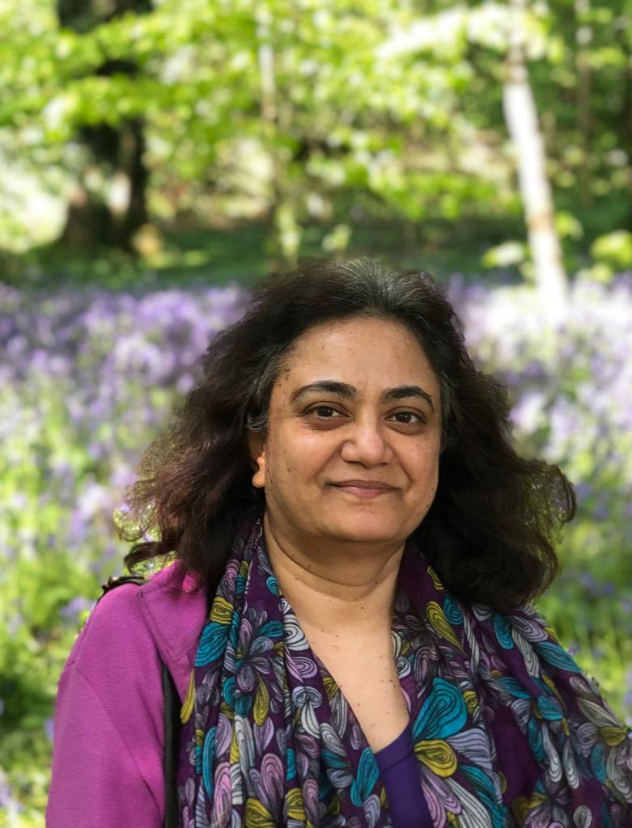 | Lakshmi Raghavachari is a dedicated HR professional with over 35+ years’ experience who has consistently demonstrated her passion for people throughout her career.  Lakshmi is currently a Snr HR Business Partner for St Albans District Council. Her HR journey commenced with a specialization in recruitment and has since expanded to encompass various aspects of human resources and people development.  Lakshmi’s extensive HR expertise spans a wide array of areas, including organizational
Re-design, change management, employee relations, procurement/contract management, compensation and rewards, as well as health and wellbeing.

Her knack for aligning HR strategies with organizational objectives is highly regarded by her clients.

Recognized for her outstanding professional acumen, Lakshmi excels in forging robust relationships with both individuals and executives. Her proficiency in navigating intricate workplace scenarios and offering solutions to complex challenges stands out as one of her core strengths.
Beyond her professional achievements, Lakshmi holds the distinction of being a Chartered member of the CIPD and actively contributes to her profession as a CIPD volunteer. Serving as the Secretary of the Herts CIPD branch, supporting a community of over 3500+ members, she participates in local events, sharing her insights on HR best practices.
Outside her HR role, Lakshmi is a passionate advocate for work-life balance and volunteering. She previously served as a Trustee for a Housing association, providing housing for individuals with mental health needs and learning disabilities.
Lakshmi Raghavachari's unwavering commitment to HR excellence, combined with her strategic mind set and dedication to employee development, positions her as an indispensable asset to any organization seeking to optimize its human capital.

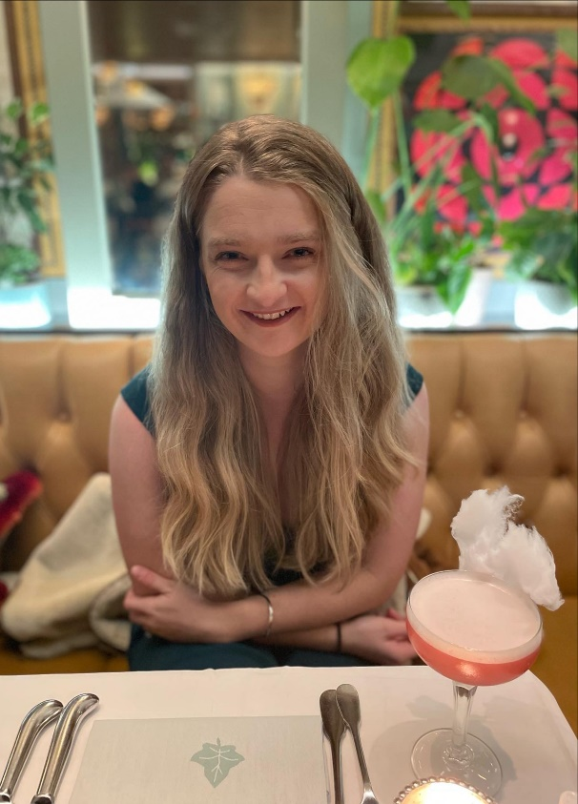 | Charlotte Wells, likes to be called Lottie has a range of experience across the food industry and consultancy, specialising strategy delivery through implementing change management. She has an MBA from Cranfield University, after graduating she was passionate about giving back to the local community. Lottie is excited to be a part of MiMH, bringing her business experience to support the charity. Lottie has lived experience with mental health challenges and supporting family members. She lives in St Albans with her husband and enjoys travelling and baking.

